Open AI CSV Data Analyser

This application allows the user to upload a small dataset in CSV format and a list of reports and get some Insight Suggestions and the results of querying those Insight Suggestions.

**To get the response for an Insight Suggestion**

Step 1 - Load CSV data by clicking the Browse button.

Step 2 – Click Analyse Data Now to get some Insight Suggestions

Step 3 – Click on a question to get a result in the chart or as text.

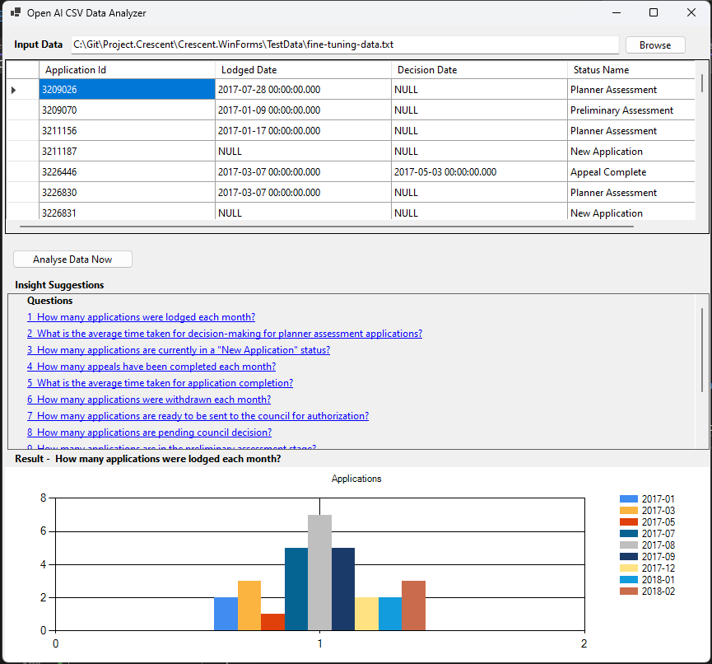

**Further Enhancement(s):**

Insight Suggestions contains reports which match the input data, and the reports can be from Ready Community (RC) or Power BI (BI). Clicking on a report link can directly open the report in Ready Community or Power BI.

